# 数据问题

# 标注问题：

**RED: 影响最大的错误**

**Purple: 不确定如何描述这个错误，粗糙理解就是模型没学好**

## Case1: 真实标签错误

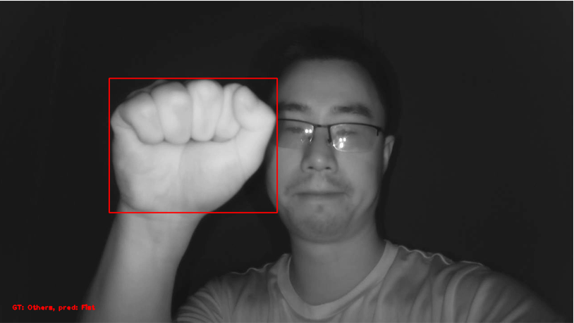 **GT:others Pred: Fist**

**有多张手掌朝外的握拳手势被打上others的标签，因此大概率训练集中存在此脏数据。**

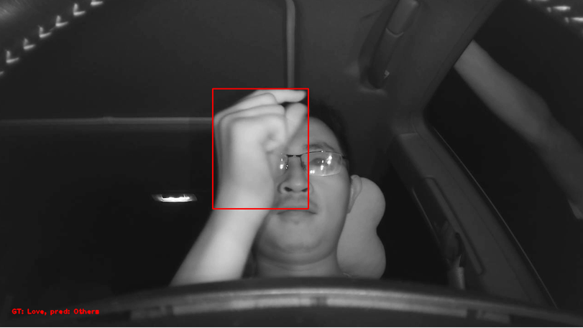 **GT: Love Pred: Others**

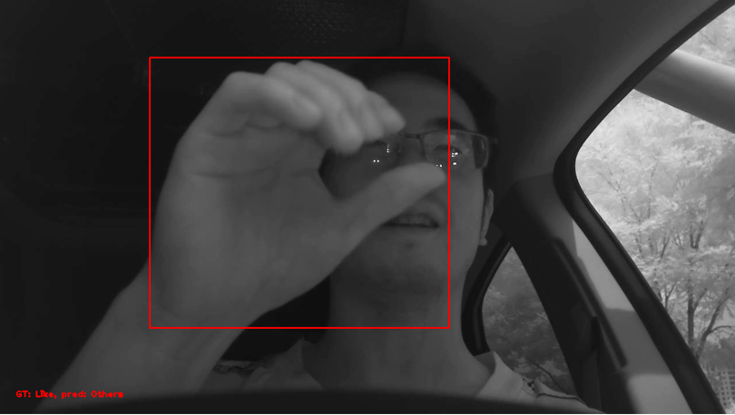 **GT: Like Pred: Others**

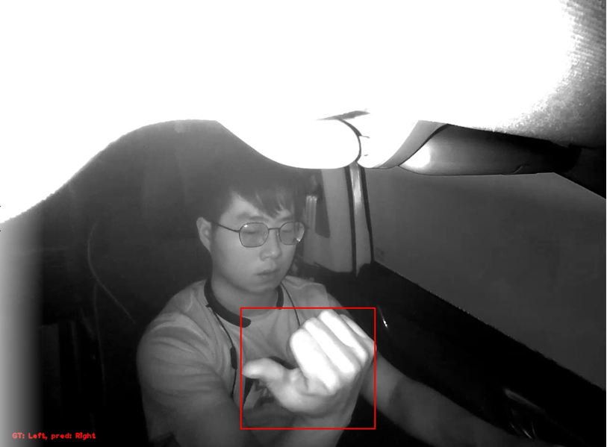 **GT: Left Pred: Right**

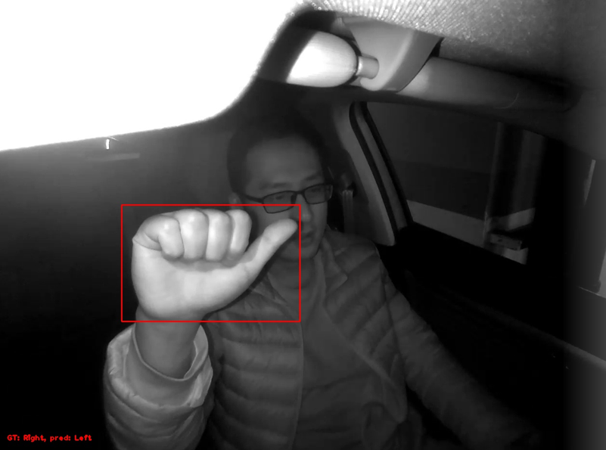 **GT: Right Pred: Left**

## Case2: 严重遮挡

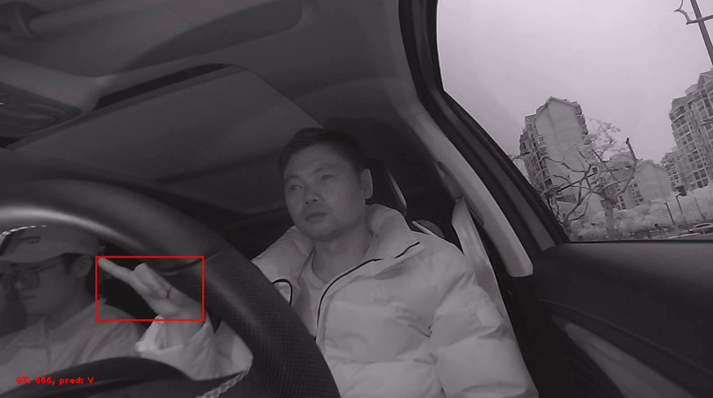 **GT: 666 Pred: V**

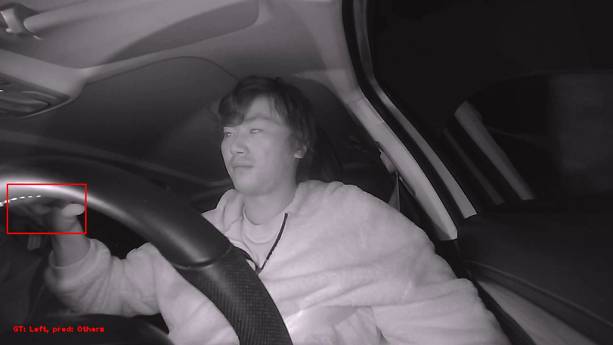 **GT: Left Pred: Others**

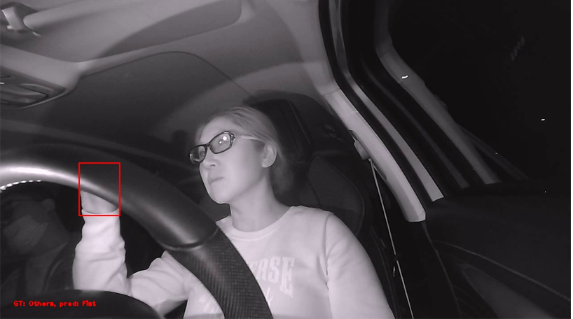 **GT: Others Pred: Fist**

**​**

## Case3: 样本存在歧义/干扰/困难

**这部分错误粗略估计会占整体错误的50%，基本就是一些特殊角度导致手势不明确**

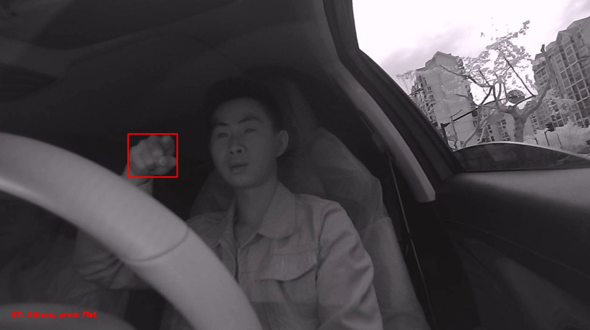 **GT: Others Pred: Fist**

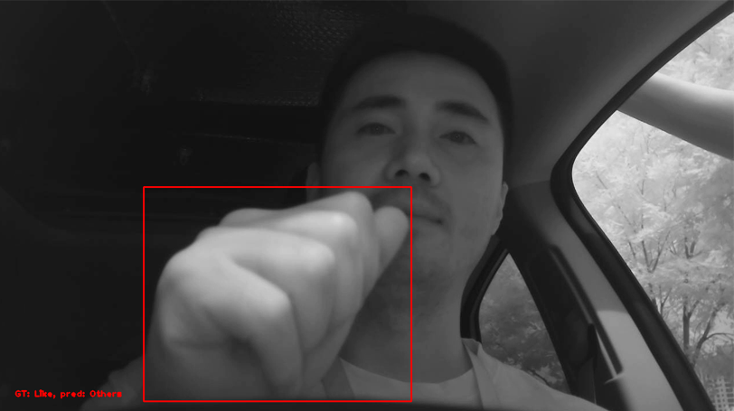 **GT: Like Pred: Others**

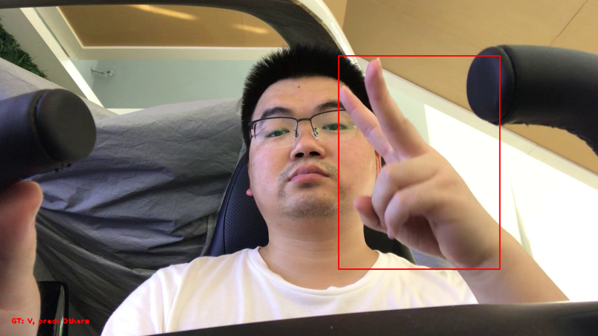 **GT: V Pred: Others**

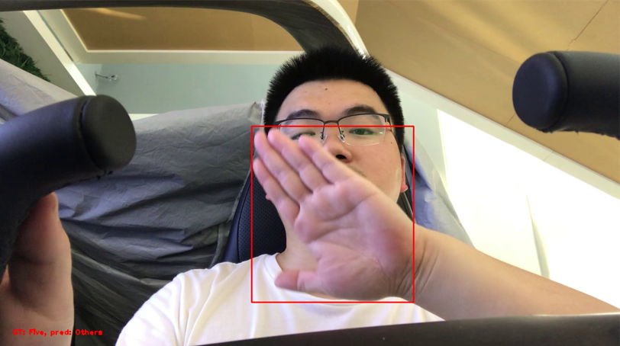 **GT: Five Pred: Others**

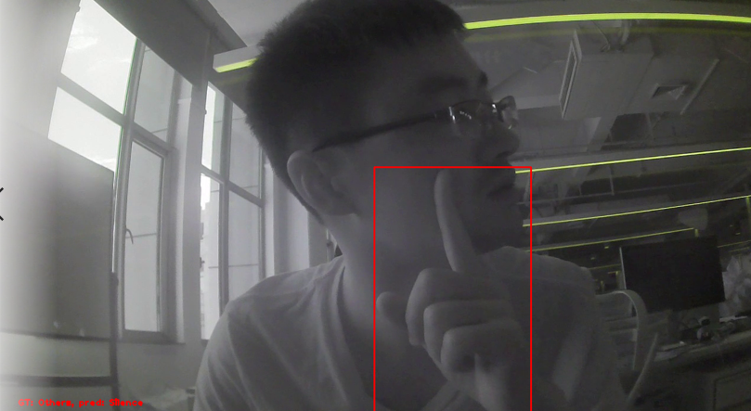 **GT: Others Pred: Silence**

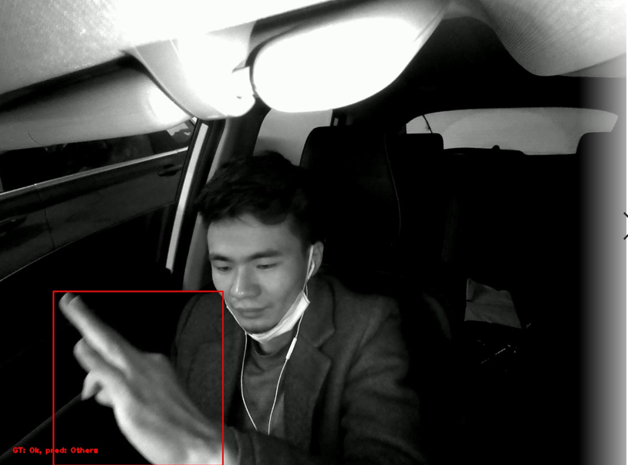 **GT: OK Pred: Others**

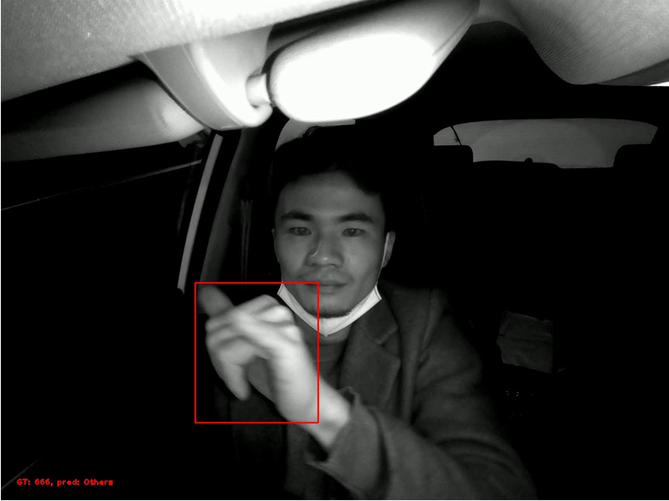 **GT: 666 Pred: Others**

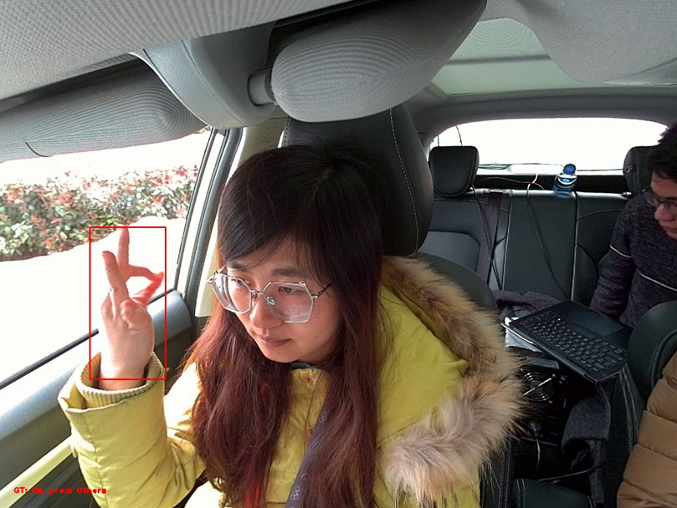 **GT: OK Pred: Others**

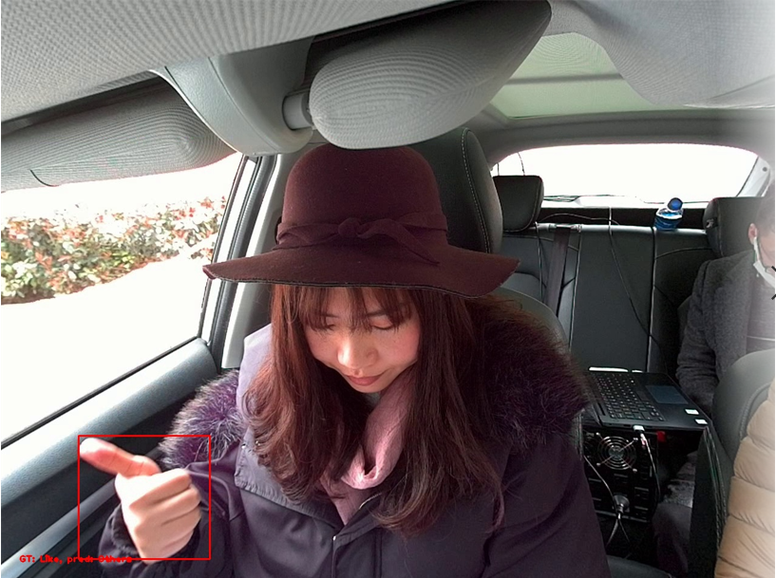 **GT: Like Pred: Others**

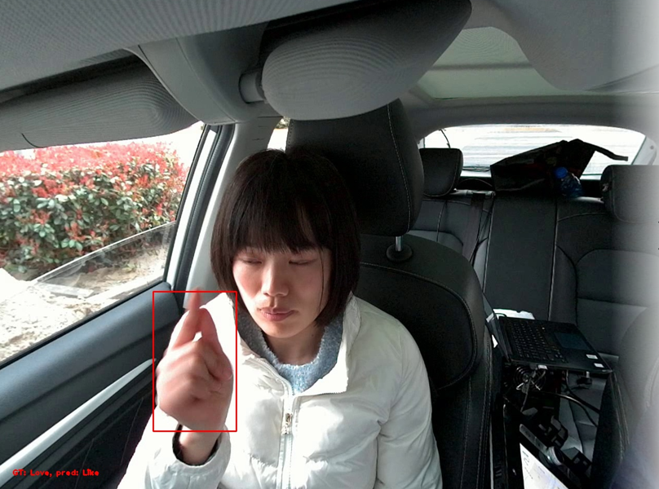 GT: Love Pred: Like

## Case4: 模糊

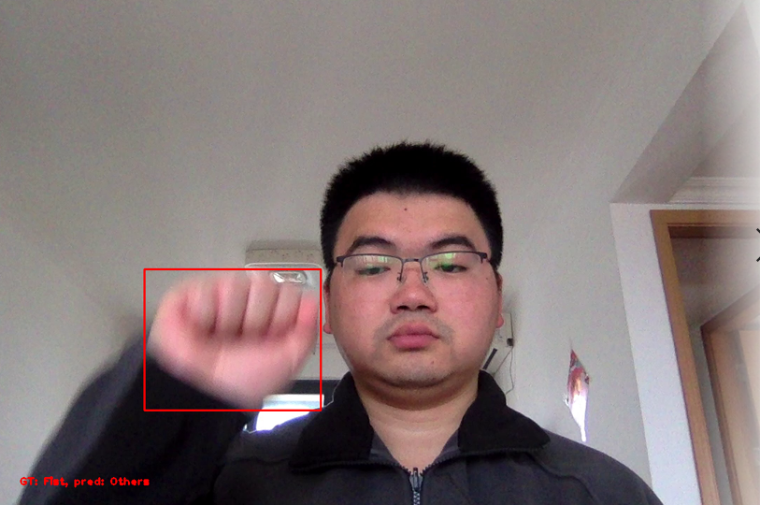 **GT: Fist Pred: Others**

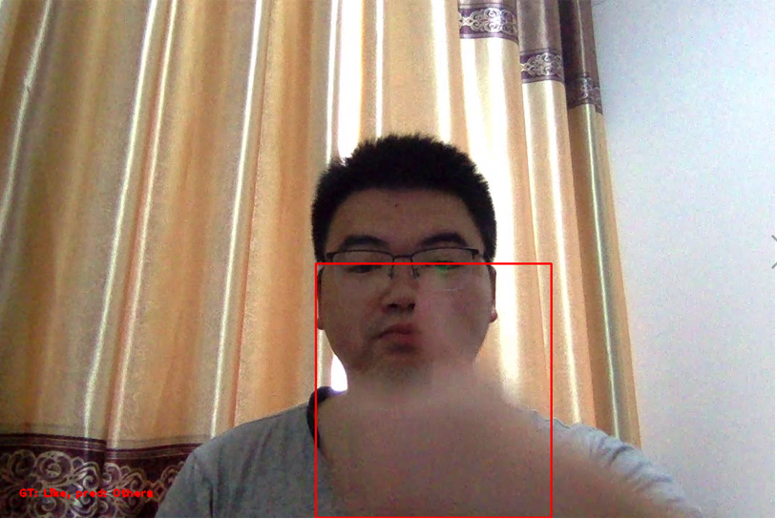 **GT: Like Pred: Others**

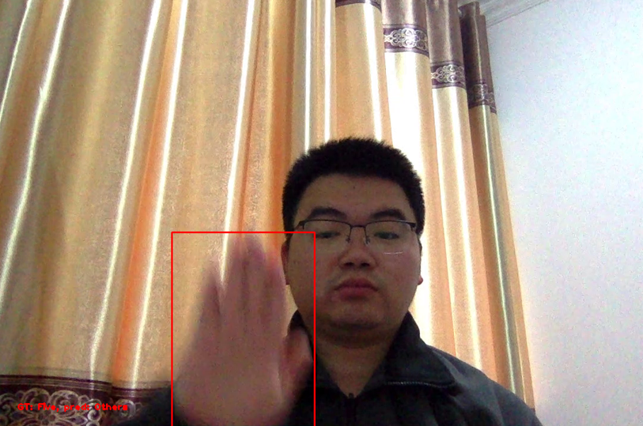 **GT: Five Pred: Others**

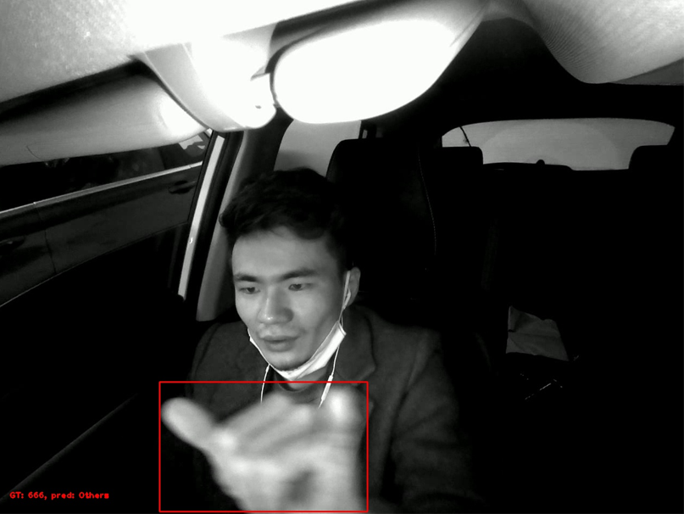 **GT: 666 Pred: Others**

## Case5: 视角导致拇指不可见/难以分辨

**主要是左右手势和666影响比较大**

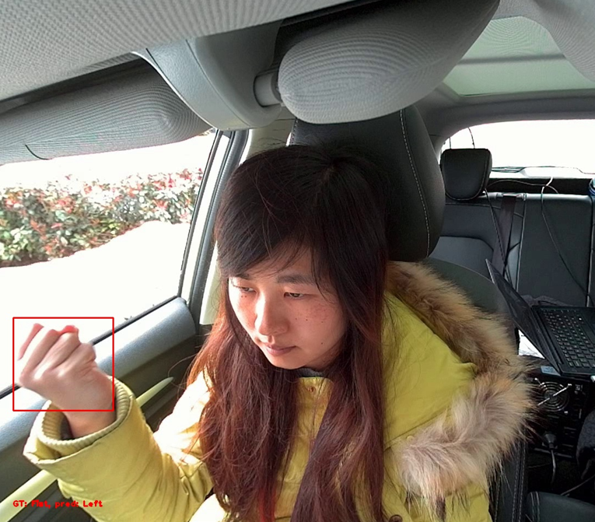 **GT: Fist Pred: Left**

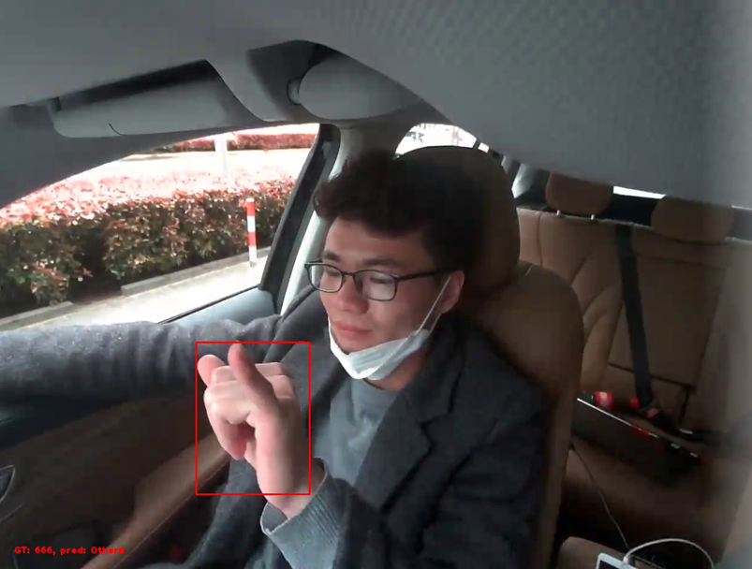 **GT: 666 Pred: Others**

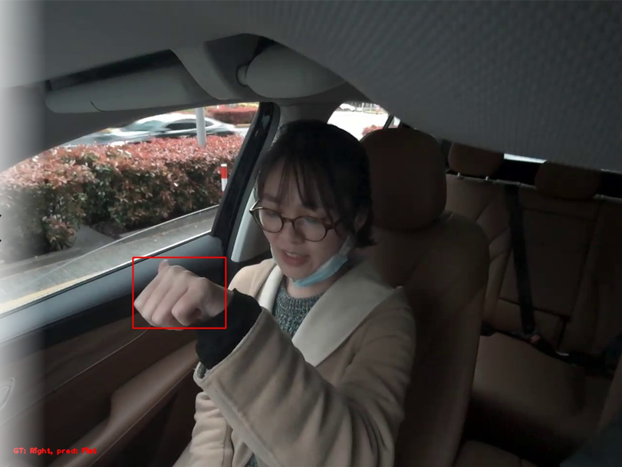 **GT: Right Pred: Fist**

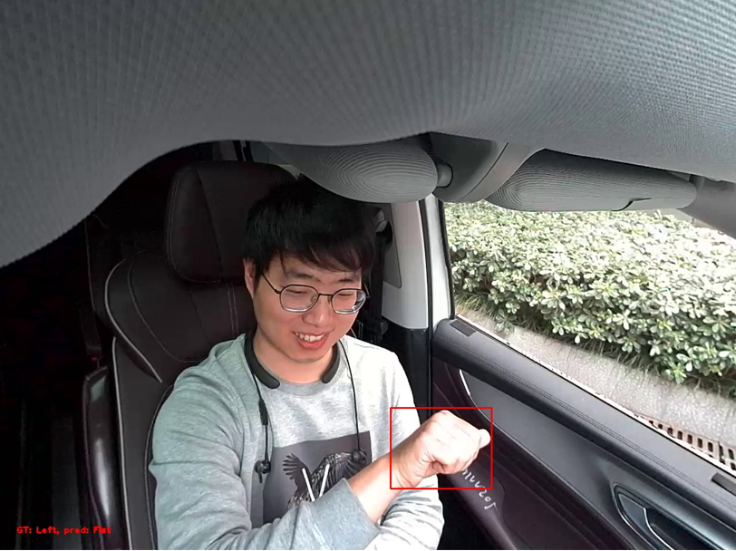 **GT: Left Pred: Fist**

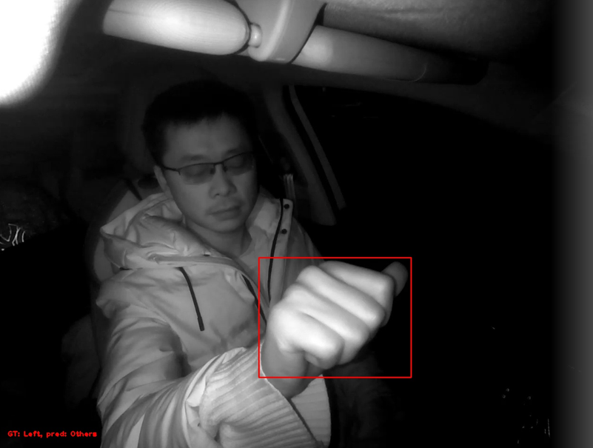 **GT: Left Pred: Others**

## Case6: 无法区分左右手做左右手势

**模型应该学到了手背，手掌的信息了，因此换手做会出错！**

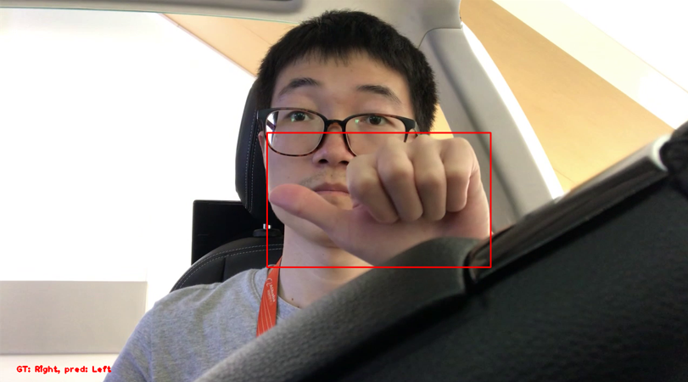 **GT: Right Pred: Left**

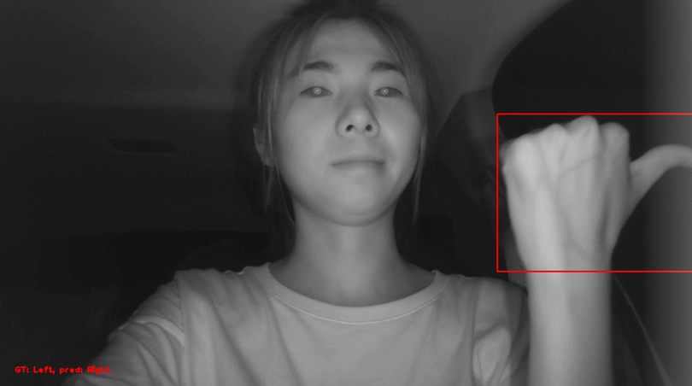 **GT: Left Pred: Right**

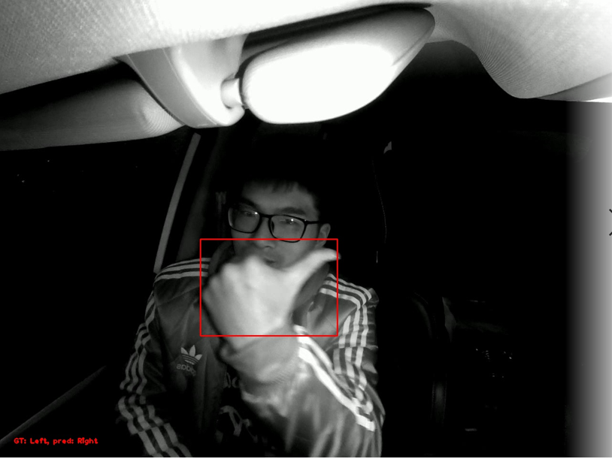 **GT: Left Pred: Right**

**​**

## Case7: 模型能力问题？

**很明显的手势识别错误，应该就是模型效果不好，没有学到真正有效的特征**

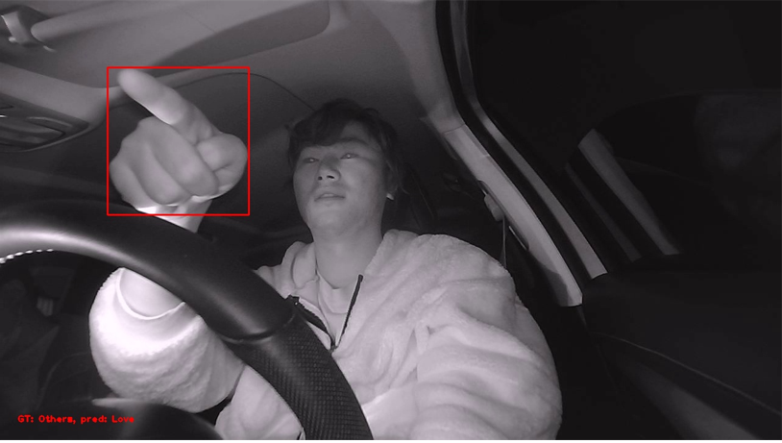 **GT: Others Pred: Love**

**​**

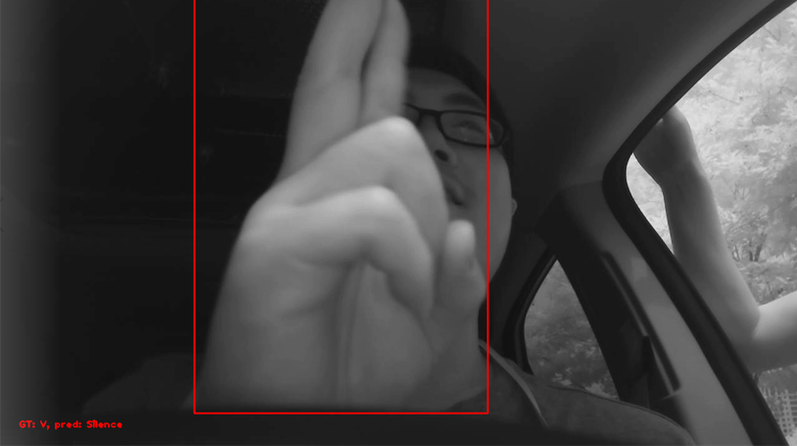 **GT: V Pred: Silence**

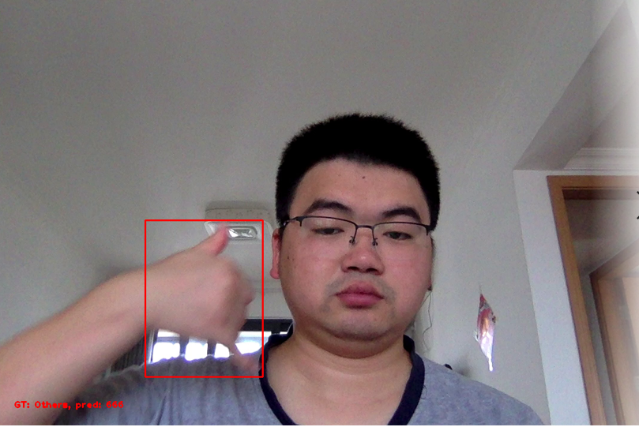 **GT: Others Pred: 666**

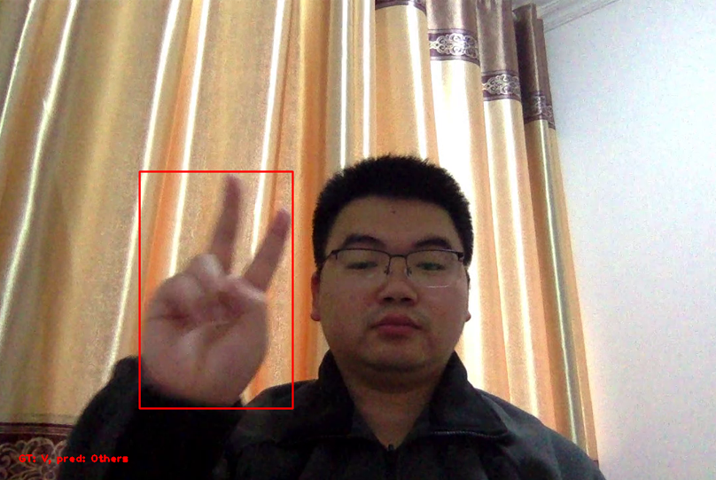 **GT: V Pred: Others**

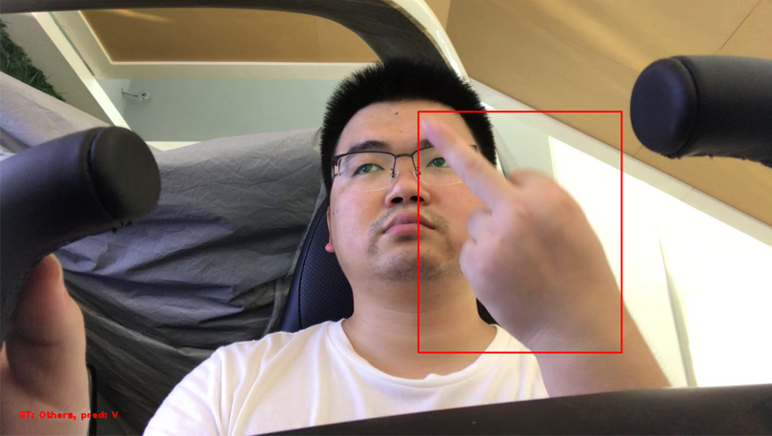 **GT: Others Pred: V**

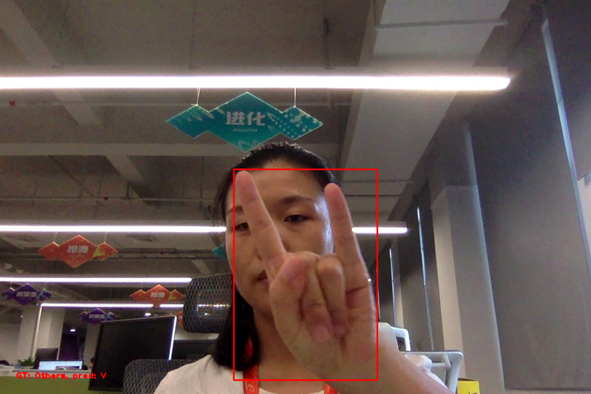 **GT: Others Pred: V**

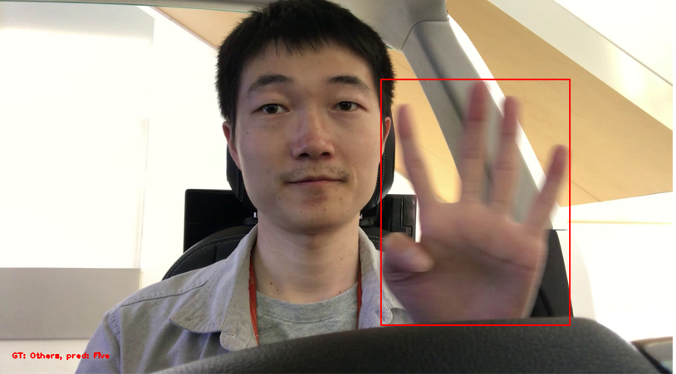 **GT: Others Pred: Five**

**此手势出现多次均识别成5！**

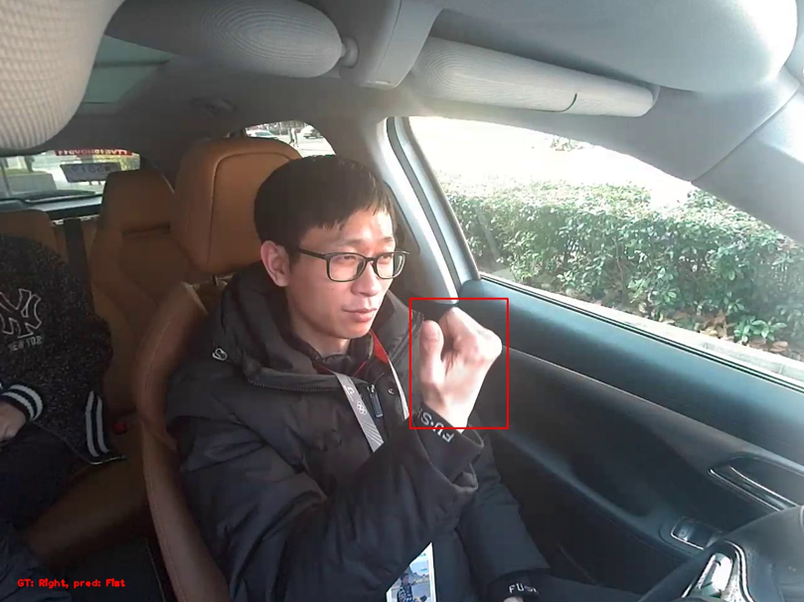 **GT: Right Pred: Fist**

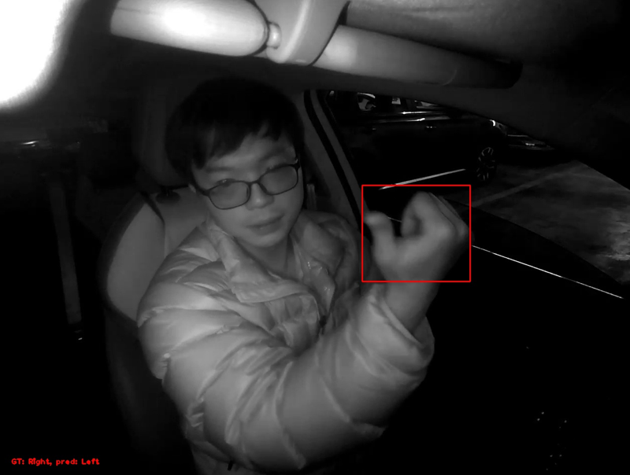 **GT: Right Pred: Left**

# 边界问题

## 一，嘘：

|  |  |  |  |  |  |  |  |  |  |
| --- | --- | --- | --- | --- | --- | --- | --- | --- | --- |
| [MISSING IMAGE: images_vs_20200331-115258_40.jpg, images_vs_20200331-115258_40.jpg ] | [MISSING IMAGE: images_1_yibiao_ground_002997.png, images_1_yibiao_ground_002997.png ] | [MISSING IMAGE: images_4_yibiao_ground_002376.png, images_4_yibiao_ground_002376.png ] | [MISSING IMAGE: images_2019-07-29-rgb-afternoon-car-1-left-and-right_004950.png, images_2019-07-29-rgb-afternoon-car-1-left-and-right_004950.png ] | [MISSING IMAGE: images_2019-09-09-ir-afternoon-car-1-left-and-right-rose_002530.png, images_2019-09-09-ir-afternoon-car-1-left-and-right-rose_002530.png ] | [MISSING IMAGE: images_2019-09-18-ir-afternoon-tearoom-left-and-right-whf-1_004160.png, images_2019-09-18-ir-afternoon-tearoom-left-and-right-whf-1_004160.png ] | [MISSING IMAGE: images_2019-08-28-ir-afternoon-car-2-left-and-right-whf_005100.png, images_2019-08-28-ir-afternoon-car-2-left-and-right-whf_005100.png ] | [MISSING IMAGE: images_3_yibiao_ground_002136.png, images_3_yibiao_ground_002136.png ] | [MISSING IMAGE: images_2019-09-18-ir-afternoon-tearoom-left-and-right-whf-2_004510.png, images_2019-09-18-ir-afternoon-tearoom-left-and-right-whf-2_004510.png ] | [MISSING IMAGE: images_vs_20200312-190440_35.jpg, images_vs_20200312-190440_35.jpg ] |
|  |  |  |  |  |  |  |  |  |  |

## 二，666

可能和**握拳，比赞，向左，向右**产生歧义

|  |  |  |  |  |  |  |  |  |  |
| --- | --- | --- | --- | --- | --- | --- | --- | --- | --- |
| [MISSING IMAGE: images_2019-07-28-rgb-afternoon-parlour-right-coat_003100.png, images_2019-07-28-rgb-afternoon-parlour-right-coat_003100.png ] | [MISSING IMAGE: images_2019-08-27-ir-morning-station-left-szm_005710.png, images_2019-08-27-ir-morning-station-left-szm_005710.png ] | [MISSING IMAGE: images_2019-07-29-rgb-afternoon-car-2-right_003930.png, images_2019-07-29-rgb-afternoon-car-2-right_003930.png ] | [MISSING IMAGE: images_2019-07-28-rgb-afternoon-room-right_004020.png, images_2019-07-28-rgb-afternoon-room-right_004020.png ] | [MISSING IMAGE: images_2019-07-30-rgb-afternoon-station-left-lh_003150.png, images_2019-07-30-rgb-afternoon-station-left-lh_003150.png ] | [MISSING IMAGE: images_2019-07-30-rgb-afternoon-station-left-lh_003090.png, images_2019-07-30-rgb-afternoon-station-left-lh_003090.png ] | [MISSING IMAGE: images_2019-08-27-ir-afternoon-station-left_006090.png, images_2019-08-27-ir-afternoon-station-left_006090.png ] | [MISSING IMAGE: images_vs_20200312-164408_115.jpg, images_vs_20200312-164408_115.jpg ] | [MISSING IMAGE: images_vs_20200312-112749_445.jpg, images_vs_20200312-112749_445.jpg ] | [MISSING IMAGE: images_vs_20200312-131531_120.jpg, images_vs_20200312-131531_120.jpg ] |
| [MISSING IMAGE: images_vs_20200331-153755_1885.jpg, images_vs_20200331-153755_1885.jpg ] | [MISSING IMAGE: 666_29_Foreward_IR_666_22.jpg, 666_29_Foreward_IR_666_22.jpg ] | [MISSING IMAGE: images_vs_20200331-144401_1860.jpg, images_vs_20200331-144401_1860.jpg ] | [MISSING IMAGE: 666_29_Foreward_RGB_666_66.jpg, 666_29_Foreward_RGB_666_66.jpg ] | [MISSING IMAGE: 666_69_Foreward_RGB_666_22.jpg, 666_69_Foreward_RGB_666_22.jpg ] |  |  |  |  |  |

## 三，V

比v手势过度阶段怎么定义

|  |  |  |  |  |  |  |  |  |  |
| --- | --- | --- | --- | --- | --- | --- | --- | --- | --- |
| [MISSING IMAGE: images_1_yibiao_cheku_000723.png, images_1_yibiao_cheku_000723.png ] | [MISSING IMAGE: images_2_yibiao_cheku_001491.png, images_2_yibiao_cheku_001491.png ] | [MISSING IMAGE: images_4_yibiao_ground_003213.png, images_4_yibiao_ground_003213.png ] | [MISSING IMAGE: images_4_yibiao_ground_003255.png, images_4_yibiao_ground_003255.png ] | [MISSING IMAGE: images_2019-07-29-rgb-afternoon-car-1-left-and-right_006180.png, images_2019-07-29-rgb-afternoon-car-1-left-and-right_006180.png ] | [MISSING IMAGE: images_2019-07-29-ir-night-bj-room-left-and-right-zw_001870.png, images_2019-07-29-ir-night-bj-room-left-and-right-zw_001870.png ] |  |  |  |  |
|  |  |  |  |  |  |  |  |  |  |

## 四，比心

比心手势类内差异太大，定义不明确，很容易和**握拳**或者**其他手势过渡阶段**产生歧义

|  |  |  |  |  |  |  |  |  |  |
| --- | --- | --- | --- | --- | --- | --- | --- | --- | --- |
| [MISSING IMAGE: images_1_yibiao_cheku_001269.png, images_1_yibiao_cheku_001269.png ] | [MISSING IMAGE: images_2019-08-09-ir-afternoon-bj-car-left-and-right-gyb_003260.png, images_2019-08-09-ir-afternoon-bj-car-left-and-right-gyb_003260.png ] | [MISSING IMAGE: images_2019-08-09-ir-afternoon-bj-car-left-and-right-zyq_000400.png, images_2019-08-09-ir-afternoon-bj-car-left-and-right-zyq_000400.png ] | [MISSING IMAGE: images_6_yibiao_cheku_001737.png, images_6_yibiao_cheku_001737.png ] | [MISSING IMAGE: images_2019-08-09-ir-afternoon-bj-car-left-and-right-zyq_000480.png, images_2019-08-09-ir-afternoon-bj-car-left-and-right-zyq_000480.png ] | [MISSING IMAGE: images_2019-08-09-ir-afternoon-bj-car-left-and-right-gyb_003280.png, images_2019-08-09-ir-afternoon-bj-car-left-and-right-gyb_003280.png ] | [MISSING IMAGE: images_vs_20200311-110247_1260.jpg, images_vs_20200311-110247_1260.jpg ] | [MISSING IMAGE: images_vs_20200312-105550_440.jpg, images_vs_20200312-105550_440.jpg ] | [MISSING IMAGE: images_vs_20200312-131531_270.jpg, images_vs_20200312-131531_270.jpg ] | [MISSING IMAGE: images_vs_20200312-152638_465.jpg, images_vs_20200312-152638_465.jpg ] |
| [MISSING IMAGE: images_vs_20200312-152952_235.jpg, images_vs_20200312-152952_235.jpg ] | [MISSING IMAGE: images_vs_20200331-151636_395.jpg, images_vs_20200331-151636_395.jpg ] |  |  |  |  |  |  |  |  |

## 五，OK

比心**手背朝前，或者侧面朝前**和正常动作差距很大

|  |  |  |  |  |  |  |  |  |  |
| --- | --- | --- | --- | --- | --- | --- | --- | --- | --- |
| [MISSING IMAGE: images_1_yibiao_ground_000306.png, images_1_yibiao_ground_000306.png ] | [MISSING IMAGE: images_3_yibiao_cheku_001479.png, images_3_yibiao_cheku_001479.png ] | [MISSING IMAGE: images_4_yibiao_cheku_001713.png, images_4_yibiao_cheku_001713.png ] | [MISSING IMAGE: images_2019-07-28-rgb-night-room-left_000050.png, images_2019-07-28-rgb-night-room-left_000050.png ] | [MISSING IMAGE: images_2019-07-29-rgb-afternoon-car-2-left_000190.png, images_2019-07-29-rgb-afternoon-car-2-left_000190.png ] | [MISSING IMAGE: images_2019-07-30-rgb-afternoon-station-left-wjh_003350.png, images_2019-07-30-rgb-afternoon-station-left-wjh_003350.png ] | [MISSING IMAGE: images_2019-07-30-rgb-afternoon-station-right-wjh_004660.png, images_2019-07-30-rgb-afternoon-station-right-wjh_004660.png ] | [MISSING IMAGE: images_2019-08-05-rgb-night-station-right-xp_000090.png, images_2019-08-05-rgb-night-station-right-xp_000090.png ] | [MISSING IMAGE: images_vs_20200311-105005_390.jpg, images_vs_20200311-105005_390.jpg ] | [MISSING IMAGE: images_vs_20200311-134915_1220.jpg, images_vs_20200311-134915_1220.jpg ] |
| [MISSING IMAGE: images_vs_20200312-191837_235.jpg, images_vs_20200312-191837_235.jpg ] |  |  |  |  |  |  |  |  |  |

## 六，比赞

姿态角增大后极易和**握拳**产生歧义，并且拇指的姿态每个差距很大

|  |  |  |  |  |  |  |  |  |  |
| --- | --- | --- | --- | --- | --- | --- | --- | --- | --- |
| [MISSING IMAGE: images_1_yibiao_ground_000345.png, images_1_yibiao_ground_000345.png ] | [MISSING IMAGE: images_2019-07-29-rgb-afternoon-car-1-left-and-right_016910.png, images_2019-07-29-rgb-afternoon-car-1-left-and-right_016910.png ] | [MISSING IMAGE: images_vs_20200311-110247_335.jpg, images_vs_20200311-110247_335.jpg ] | [MISSING IMAGE: images_vs_20200312-121347_335.jpg, images_vs_20200312-121347_335.jpg ] | [MISSING IMAGE: images_vs_20200312-122600_405.jpg, images_vs_20200312-122600_405.jpg ] | [MISSING IMAGE: images_vs_20200312-131531_435.jpg, images_vs_20200312-131531_435.jpg ] | [MISSING IMAGE: images_vs_20200312-131531_455.jpg, images_vs_20200312-131531_455.jpg ] | [MISSING IMAGE: images_vs_20200312-155639_325.jpg, images_vs_20200312-155639_325.jpg ] | [MISSING IMAGE: images_vs_20200312-164408_490.jpg, images_vs_20200312-164408_490.jpg ] | [MISSING IMAGE: train_1202_wq_nod_hand_3840.jpg, train_1202_wq_nod_hand_3840.jpg ] |
| [MISSING IMAGE: train_1217_nalei_hand1_5750.jpg, train_1217_nalei_hand1_5750.jpg ] | [MISSING IMAGE: train_1217_zhangjiawei_hand_1240.jpg, train_1217_zhangjiawei_hand_1240.jpg ] |  |  |  |  |  |  |  |  |

## 七，握拳

握拳主要是容易和**干扰动作，过渡动作，左右手势**产生歧义，比如比赞，比五等的过渡

|  |  |  |  |  |  |  |  |  |  |
| --- | --- | --- | --- | --- | --- | --- | --- | --- | --- |
| [MISSING IMAGE: images_1_yibiao_cheku_002139.png, images_1_yibiao_cheku_002139.png ] | [MISSING IMAGE: images_1_yibiao_ground_001419.png, images_1_yibiao_ground_001419.png ] | [MISSING IMAGE: images_2019-07-28-rgb-afternoon-parlour-left_003590.png, images_2019-07-28-rgb-afternoon-parlour-left_003590.png ] | [MISSING IMAGE: images_3_yibiao_cheku_000816.png, images_3_yibiao_cheku_000816.png ] | [MISSING IMAGE: images_5_yibiao_cheku_000048.png, images_5_yibiao_cheku_000048.png ] | [MISSING IMAGE: images_2019-08-09-ir-afternoon-bj-car-left-and-right-ll_001390.png, images_2019-08-09-ir-afternoon-bj-car-left-and-right-ll_001390.png ] | [MISSING IMAGE: images_2019-08-26-ir-night-station-right-whf_011810.png, images_2019-08-26-ir-night-station-right-whf_011810.png ] | [MISSING IMAGE: Fist_44_Foreward_IR_Fist_66.jpg, Fist_44_Foreward_IR_Fist_66.jpg ] | [MISSING IMAGE: Fist_34_Foreward_RGB_Fist_176.jpg, Fist_34_Foreward_RGB_Fist_176.jpg ] |  |
|  |  |  |  |  |  |  |  |  |  |

## 八，手掌/比五

|  |  |  |  |  |  |  |  |  |  |
| --- | --- | --- | --- | --- | --- | --- | --- | --- | --- |
| [MISSING IMAGE: images_vs_20200312-115757_820.jpg, images_vs_20200312-115757_820.jpg ] | [MISSING IMAGE: images_vs_20200312-130633_505.jpg, images_vs_20200312-130633_505.jpg ] | [MISSING IMAGE: images_vs_20200312-192113_455.jpg, images_vs_20200312-192113_455.jpg ] | [MISSING IMAGE: images_vs_20200331-151636_1030.jpg, images_vs_20200331-151636_1030.jpg ] | [MISSING IMAGE: images_vs_20200311-105005_905.jpg, images_vs_20200311-105005_905.jpg ] | [MISSING IMAGE: images_vs_20200312-131531_900.jpg, images_vs_20200312-131531_900.jpg ] | [MISSING IMAGE: images_2019-07-28-rgb-afternoon-parlour-right-coat_001360.png, images_2019-07-28-rgb-afternoon-parlour-right-coat_001360.png ] | [MISSING IMAGE: images_2019-07-28-rgb-afternoon-parlour-right_005660.png, images_2019-07-28-rgb-afternoon-parlour-right_005660.png ] | [MISSING IMAGE: images_2019-07-30-rgb-afternoon-station-left-wjh_004880.png, images_2019-07-30-rgb-afternoon-station-left-wjh_004880.png ] | [MISSING IMAGE: images_2019-08-26-ir-afternoon-station-right_007040.png, images_2019-08-26-ir-afternoon-station-right_007040.png ] |
| [MISSING IMAGE: images_2019-09-18-ir-afternoon-station-left_007730.png, images_2019-09-18-ir-afternoon-station-left_007730.png ] |  |  |  |  |  |  |  |  |  |

## 九，向左

极易和**比赞，握拳**产生歧义

|  |  |  |  |  |  |  |  |  |  |
| --- | --- | --- | --- | --- | --- | --- | --- | --- | --- |
| [MISSING IMAGE: images_1_yibiao_cheku_000951.png, images_1_yibiao_cheku_000951.png ] | [MISSING IMAGE: images_2_yibiao_ground_001890.png, images_2_yibiao_ground_001890.png ] | [MISSING IMAGE: images_2019-08-01-rgb-afternoon-bj-station-left-and-right-gd_000736.png, images_2019-08-01-rgb-afternoon-bj-station-left-and-right-gd_000736.png ] | [MISSING IMAGE: images_2019-08-07-rgb-afternoon-car-2-right-rose_003810.png, images_2019-08-07-rgb-afternoon-car-2-right-rose_003810.png ] | [MISSING IMAGE: images_2019-07-28-rgb-afternoon-parlour-left_005290.png, images_2019-07-28-rgb-afternoon-parlour-left_005290.png ] | [MISSING IMAGE: images_2019-08-07-rgb-afternoon-car-2-left-and-right-coat-2-wjh_002550.png, images_2019-08-07-rgb-afternoon-car-2-left-and-right-coat-2-wjh_002550.png ] | [MISSING IMAGE: images_2019-08-09-ir-afternoon-bj-car-left-and-right-gyb_000080.png, images_2019-08-09-ir-afternoon-bj-car-left-and-right-gyb_000080.png ] | [MISSING IMAGE: images_2019-08-28-ir-afternoon-station-left-and-right-gyb_001060.png, images_2019-08-28-ir-afternoon-station-left-and-right-gyb_001060.png ] | [MISSING IMAGE: images_2019-09-18-ir-afternoon-station-left_006690.png, images_2019-09-18-ir-afternoon-station-left_006690.png ] | [MISSING IMAGE: images_2019-09-24-ir-morning-station-left-and-right-whf_011820.png, images_2019-09-24-ir-morning-station-left-and-right-whf_011820.png ] |
| [MISSING IMAGE: images_vs_20200312-115757_1005.jpg, images_vs_20200312-115757_1005.jpg ] | [MISSING IMAGE: images_vs_20200312-122600_425.jpg, images_vs_20200312-122600_425.jpg ] | [MISSING IMAGE: train_1029_gd_hand_1_140.jpg, train_1029_gd_hand_1_140.jpg ] | [MISSING IMAGE: train_1029_gd_hand_1_2110.jpg, train_1029_gd_hand_1_2110.jpg ] | [MISSING IMAGE: train_1029_wj_hand_4800.jpg, train_1029_wj_hand_4800.jpg ] | [MISSING IMAGE: train_1217_huzhuqing_hand_120.jpg, train_1217_huzhuqing_hand_120.jpg ] | [MISSING IMAGE: train_1217_nalei_hand1_6150.jpg, train_1217_nalei_hand1_6150.jpg ] |  |  |  |

## 十，向右

极易和**比赞，握拳**产生歧义

|  |  |  |  |  |  |  |  |  |  |
| --- | --- | --- | --- | --- | --- | --- | --- | --- | --- |
| [MISSING IMAGE: val5_1_0108_chenyanhua_hand1_5742.jpg, val5_1_0108_chenyanhua_hand1_5742.jpg ] | [MISSING IMAGE: val5_1_chenguoqiang_hand0111_2156.jpg, val5_1_chenguoqiang_hand0111_2156.jpg ] | [MISSING IMAGE: val6_1_hand_likangmao_1140.jpg, val6_1_hand_likangmao_1140.jpg ] | [MISSING IMAGE: val5_1_0106_guandai_hand2_5168.jpg, val5_1_0106_guandai_hand2_5168.jpg ] | [MISSING IMAGE: val6_3_1225_lujiawei_bug1_255.jpg, val6_3_1225_lujiawei_bug1_255.jpg ] | [MISSING IMAGE: train_1029_gd_hand_1_410.jpg, train_1029_gd_hand_1_410.jpg ] | [MISSING IMAGE: train_1029_gd_hand_1_2940.jpg, train_1029_gd_hand_1_2940.jpg ] | [MISSING IMAGE: train_1029_wj_hand_3904.jpg, train_1029_wj_hand_3904.jpg ] | [MISSING IMAGE: train_1202_gd_hand3_1875.jpg, train_1202_gd_hand3_1875.jpg ] | [MISSING IMAGE: images_2019-07-29-rgb-afternoon-car-1-left_001330.png, images_2019-07-29-rgb-afternoon-car-1-left_001330.png ] |
| [MISSING IMAGE: images_1_yibiao_ground_001575.png, images_1_yibiao_ground_001575.png ] | [MISSING IMAGE: images_2019-08-01-rgb-afternoon-bj-station-left-and-right-gd_002464.png, images_2019-08-01-rgb-afternoon-bj-station-left-and-right-gd_002464.png ] | [MISSING IMAGE: images_2019-08-09-rgb-afternoon-bj-car-left-and-right-gyb-1_000160.png, images_2019-08-09-rgb-afternoon-bj-car-left-and-right-gyb-1_000160.png ] | [MISSING IMAGE: images_2019-08-27-ir-afternoon-station-left-rose_002390.png, images_2019-08-27-ir-afternoon-station-left-rose_002390.png ] |  |  |  |  |  |  |

# 数据清洗：

## 1.第1~3轮：

|  |  |  |
| --- | --- | --- |
| **Case ID** | **具体问题** | **解决方案** |
| **1** | 标签错误 | 重打标 |
| **2** | 严重遮挡 | 删除 |
| **3** | 歧义/困难/干扰 | 加上难例标签/重打标 |
| **4** | 模糊 | 打others标 |
| **5** | 自身遮挡 | 重打标 |
| **6** | 左右手 | 加难例标签 |

***\*\*\*PS: 难例中并未继续再细分，后续清洗可能需要继续细增加标签\*\*\****

|  |  |  |  |  |  |  |
| --- | --- | --- | --- | --- | --- | --- |
| ***TBD: To Be Done OG: On Going DN: Done*** | | | | | | |
| **Case ID** | **1** | **2** | **3** | **4** | **5** | **6** |
| **Dataset​** | **Progress** | | | | | |
| **data1** | **DN** | **DN** | **DN** | **DN** | **DN** | **DN** |
| **data2** | **DN** | **DN** | **DN** | **DN** | **DN** | **DN** |
| **data3** | **TBD** | **TBD** | **TBD** | **TBD** | **TBD** | **TBD** |
| **data4** | **DN** | **DN** | **DN** | **DN** | **DN** | **DN** |
| **data5_1** | **DN** | **DN** | **DN** | **DN** | **DN** | **DN** |
| **data5_2** | **DN** | **DN** | **DN** | **DN** | **DN** | **DN** |
| **data6(A)** | **DN** | **DN** | **TBD** | **TBD** | **TBD** | **TBD** |
| **data7(数据堂)** | **TBD** | **TBD** | **TBD** | **TBD** | **TBD** | **TBD** |

## 2.第4轮：

|  |  |  |
| --- | --- | --- |
| **Case ID** | **具体问题** | **解决方案** |
| **1** | 困难 | hard=1 |
| **2** | 歧义/干扰 | hard=2 |
| **3** | 模糊 | hard=2 |
| **4** | 自身遮挡 | hard=2 |

|  |  |  |  |  |
| --- | --- | --- | --- | --- |
| ***TBD: To Be Done OG: On Going DN: Done*** | | | | |
| **Case ID** | **1** | **2** | **3** | **4** |
| **Dataset​** | **Progress** | | | |
| **data1** | ***DN*** | ***DN*** | ***DN*** | ***DN*** |
| **data2** | ***DN*** | ***DN*** | ***DN*** | ***DN*** |
| **data3** | ***DN*** | ***DN*** | ***DN*** | ***DN*** |
| **data4** | ***DN*** | ***DN*** | ***DN*** | ***DN*** |
| **data5_1** | ***DN*** | ***DN*** | ***DN*** | ***DN*** |
| **data5_2** | ***DN*** | ***DN*** | ***DN*** | ***DN*** |
| **data6(A)** | ***DN*** | ***DN*** | ***DN*** | ***DN*** |
| **data7(数据堂)** | **TBD** | **TBD** | **TBD** | **TBD** |

## 3.数据去重20211222：

***采取策略为：隔帧采样。***

1）将具有相同键（上级目录名+图像名去除最后帧号）的样本聚集在一起。

2）采样第一帧到队列中，初始化历史帧为当前帧

3）如果当前帧与上一帧的帧差大于阈值，则采样此帧，并跟新历史帧为当前帧

4）其他情况则仅更新历史帧为当前帧

5）跳过所有干扰样本和未打困难/干扰标签样本

data1: n = 20，source sampers/destination sampers=27710/11691

data2: n = 20，source sampers/destination sampers=12327/2492

data4: n = 30， source sampers/destination sampers=29840/4553

data5_1: n = 20，source sampers/destination sampers=12649/802

data5_2: n = 15，source sampers/destination sampers=3419/625

example:

[MISSING IMAGE: image.png, image.png ]

[MISSING IMAGE: image.png, image.png ]

​

***​***

# 初步解决方案：

1.清洗数据

2.清洗后数据上训练，测试

3.分析问题是否解决

4.重复1~3